ASSIGNMENT 2

Name: SURIYA LAKSHMI A

Roll No:720719104161

* **Task 1:Sales By Customer.**

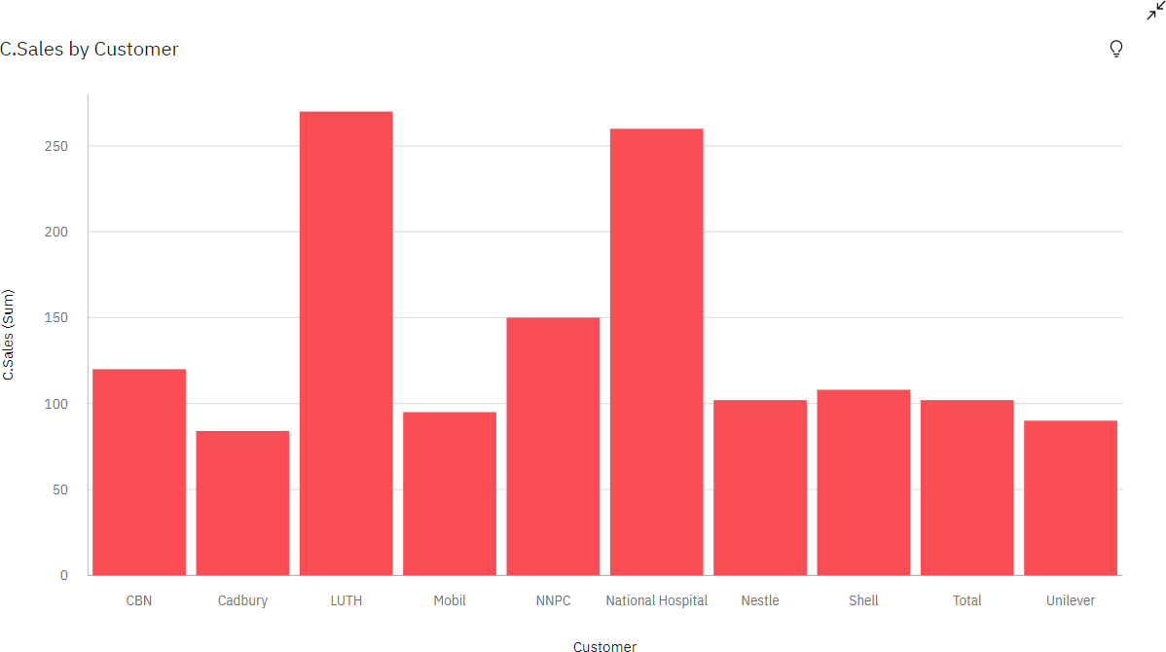

* **Task 2: Sales By Location.**

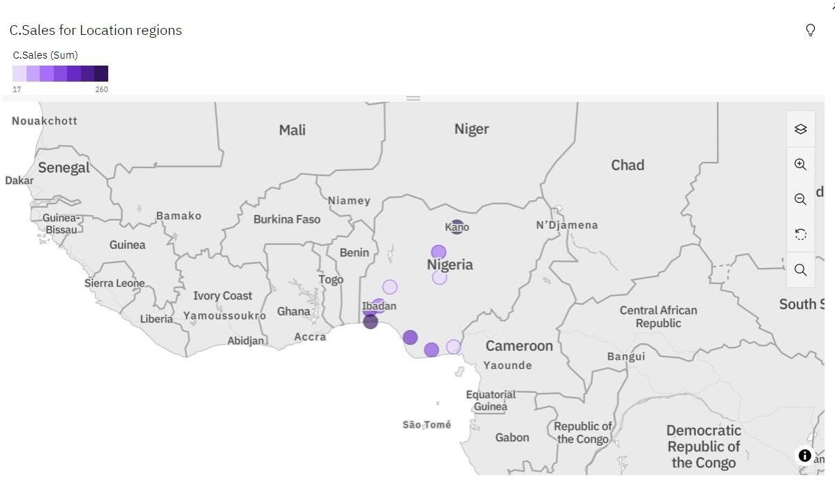

* **Task 3: Sales By Sales Representative.**

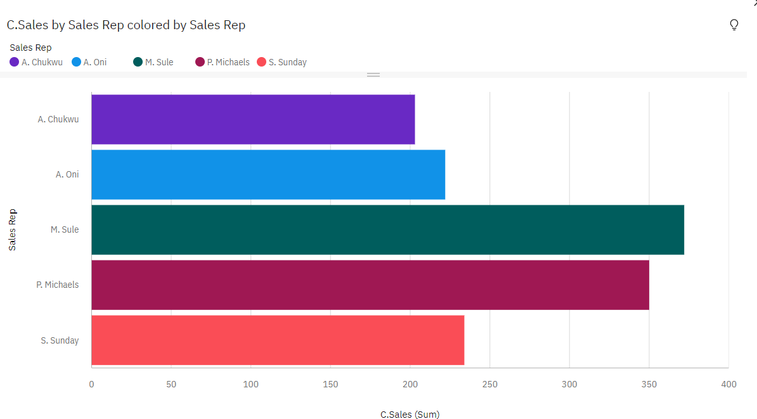

* **Task 4: Received Inventory From Supplier**

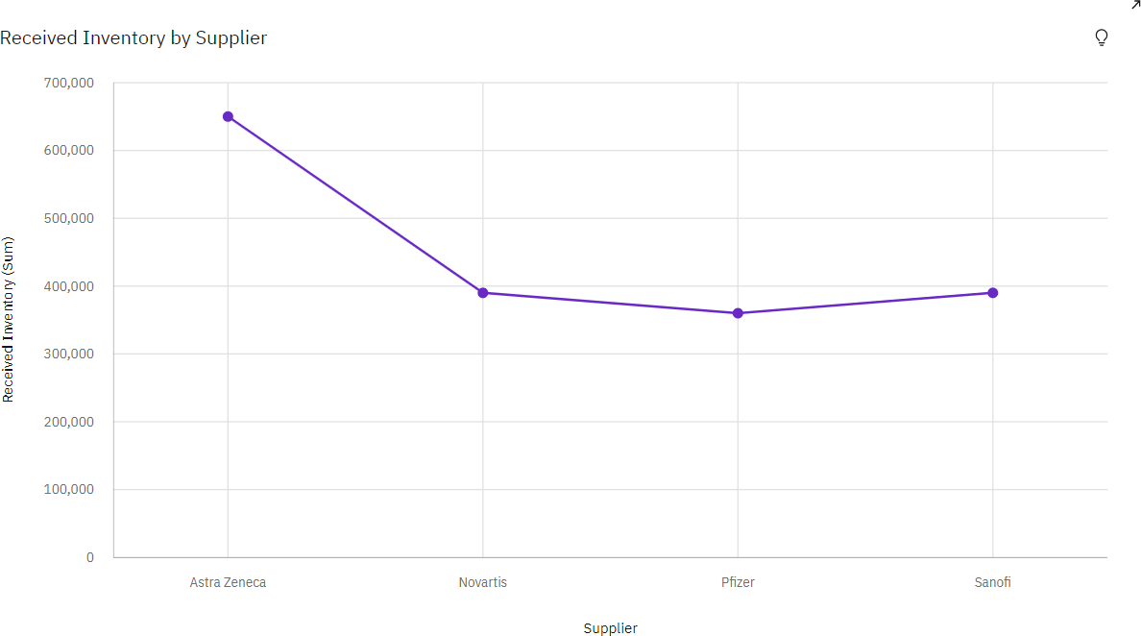

* **Task 5: Inventory Stock for Warehouse Locations**

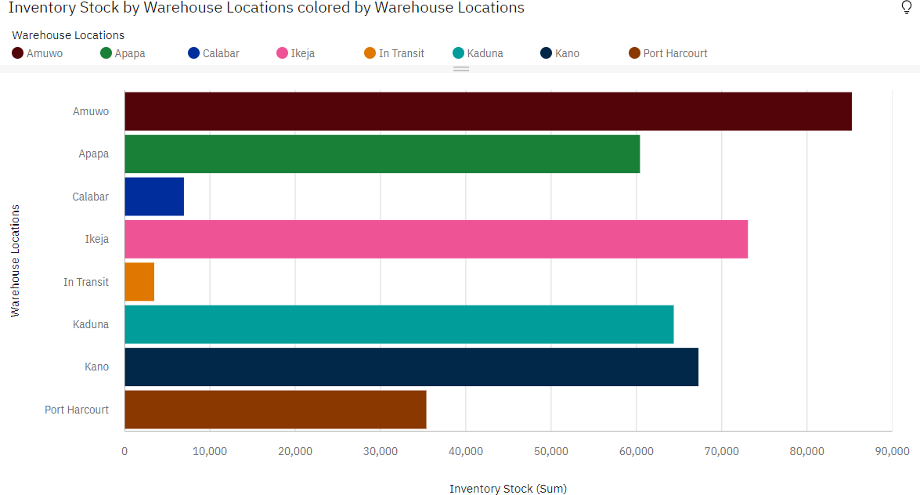

* **Task 6: Sales Trend**

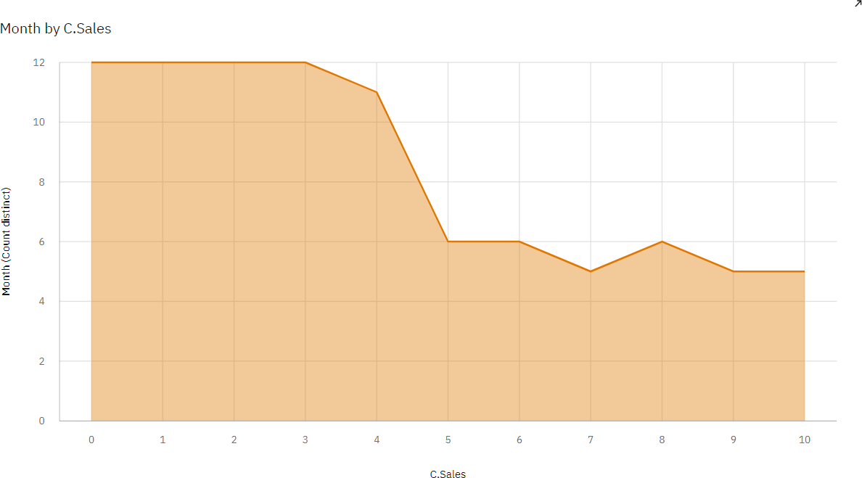

* **Task 7:Monthly Sales**

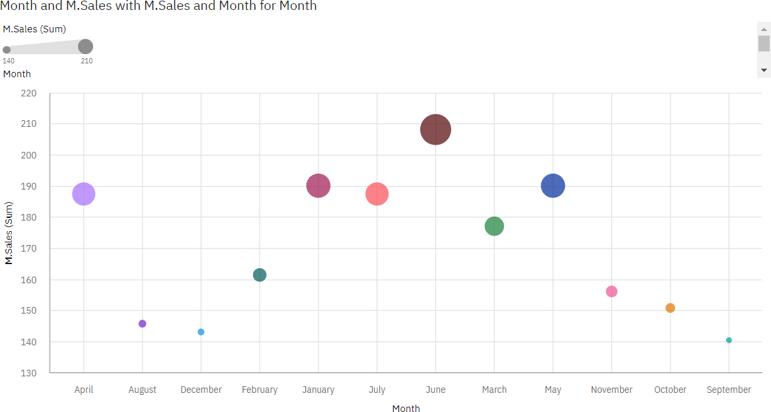

* **Task 8: Actual and Received Inventory by Month**

